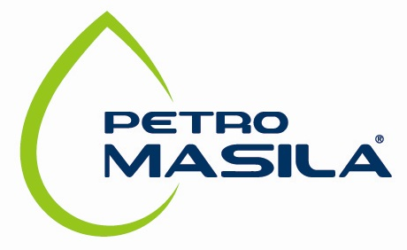

Masila Petroleum Exploration and Production Company
P.O. Box 15137
Villa 131, Hadda Street
Sana’a, Republic of Yemen

NEW CHILD PAYMENT

To: | FIELD HUMAN RESOURCES | Date:_21-SEP-2025
Subject: | Payment of Child’s Birth Expenses
Child’s Name: | Ameen Nasser Hussain Bin-Taleb _______
Sex: | ___M_____________________________
Birth day: | _12-04-2025_______________________________
Hospital’s Name: | ____Sayioun____________________________
Status of Hospital: | Contracted Non-Contracted
Method of Payment: | Invoice reimbursement Lump Sum

Applicant’s Name: | _ Nasser Hussain Bin-Taleb ______
EY#: | _____ 120 _________________
Signature: | _______________________________

Please attach the following with your application:

The medical report.
Child birth certificate.

